**IBM Bluemix-Eclipse IDE Integration**

**Step 1**  : Install IBM blue mix tools in Eclipse IDE

Go to **Help —> Eclipse Marketplace**

**Step 2 :**  Search for IBM blue mix and install below software IBM Eclipse tools for Bluemix for Neon: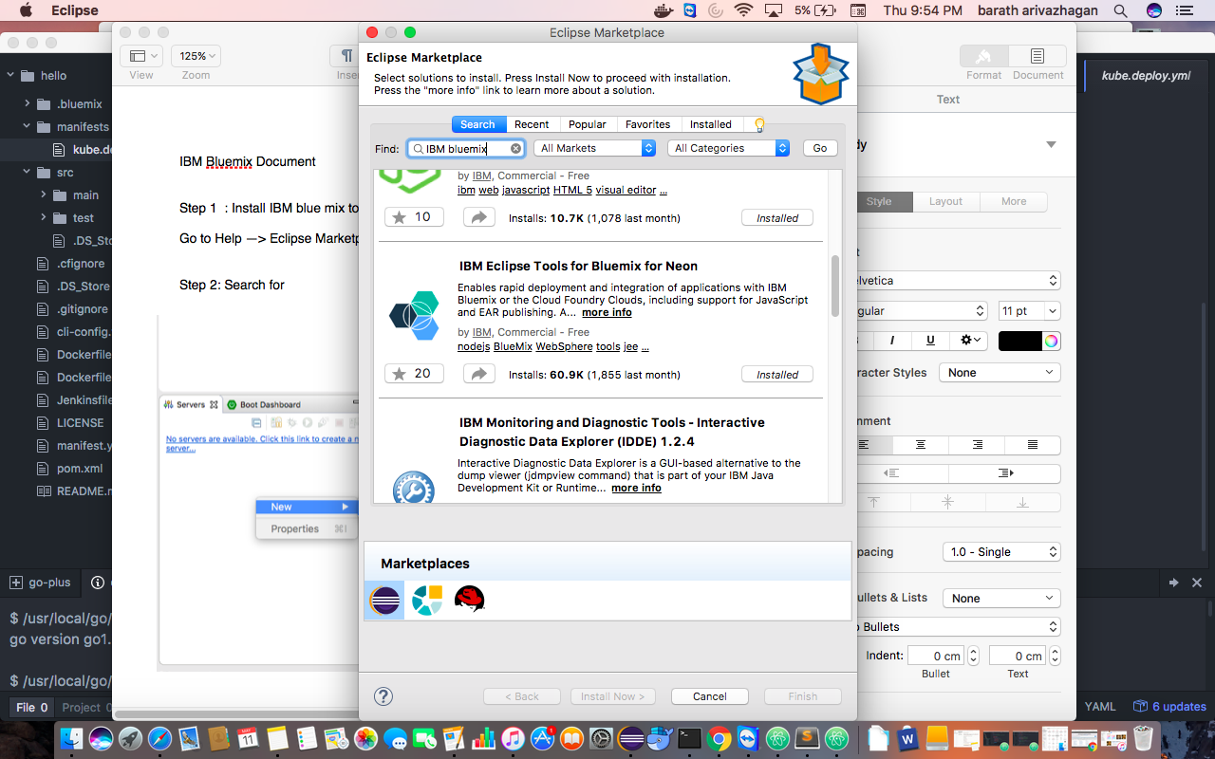

**Step 3:**  Once Software is installed. Restart the Eclipse IDE and create a new server

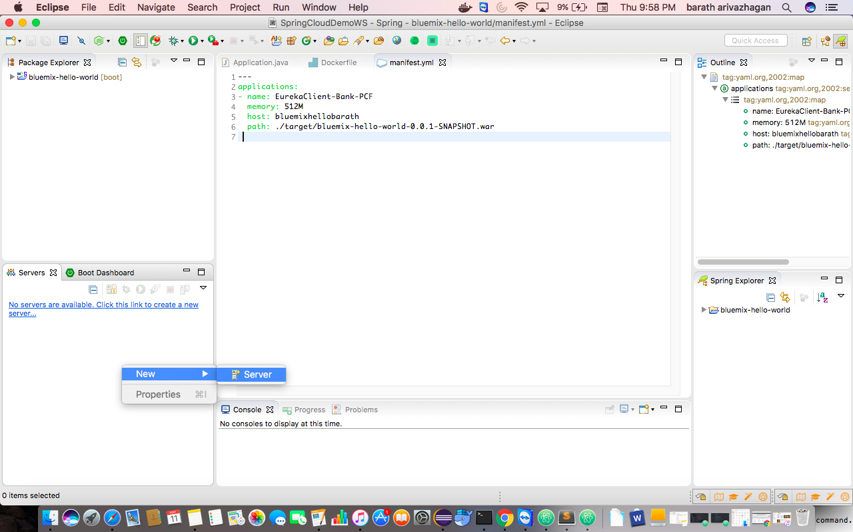

**Step 4**: Choose **IBM —> IBM Bluemix** as below:

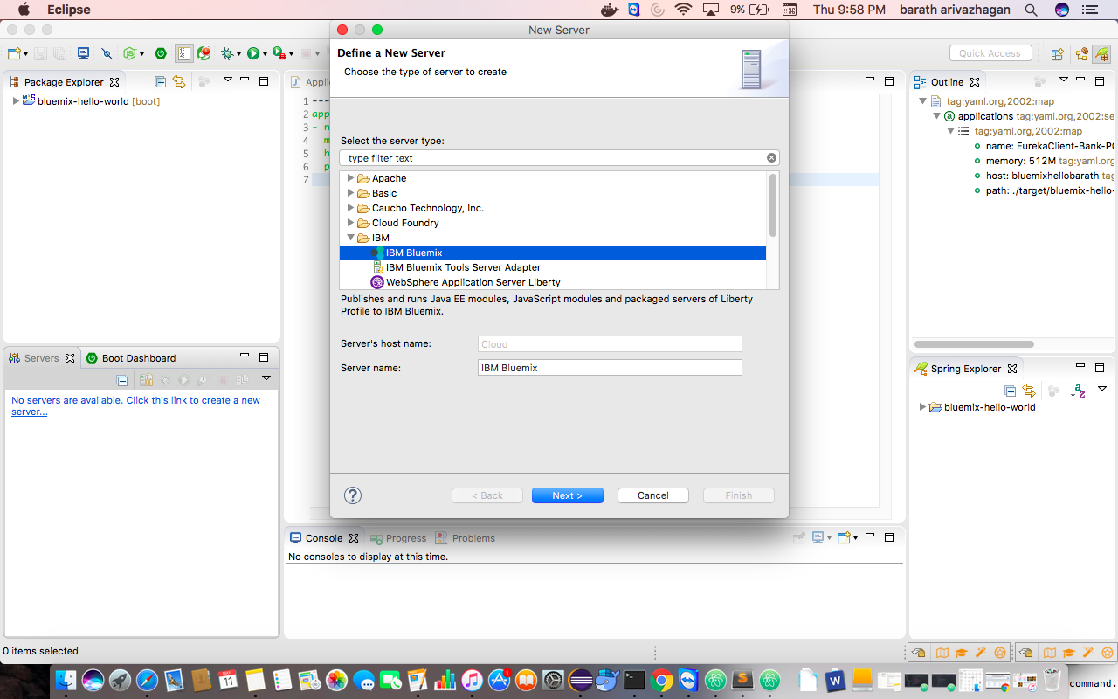

**Step 5**: Click on Next and enter the IBM Bluemix account credentials

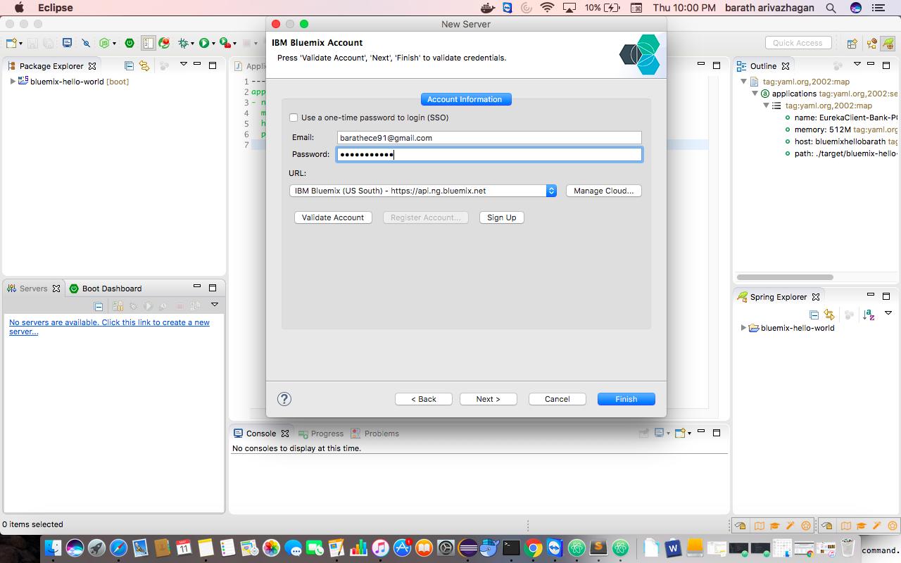

**Step 6**: Click on validate to validate the account . Click on next to choose the space to work with as below :

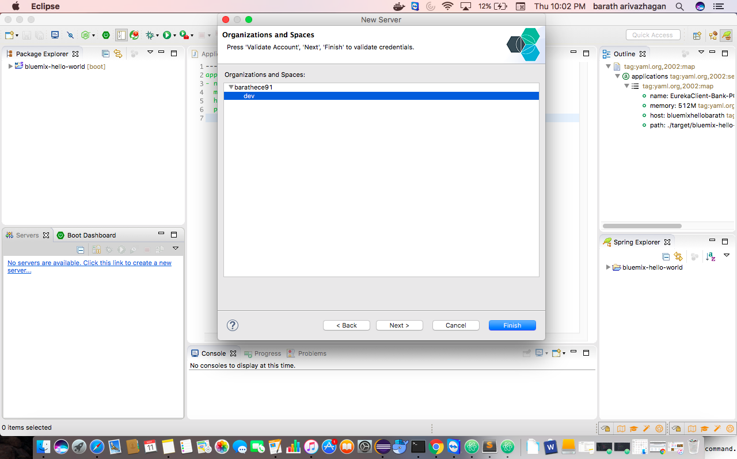

**Step 7**: Once the space is chosen. Click on finish to set up the cloud server

**Step 8** : Create a simple spring boot application by clicking on

**New —> Spring Starter Project**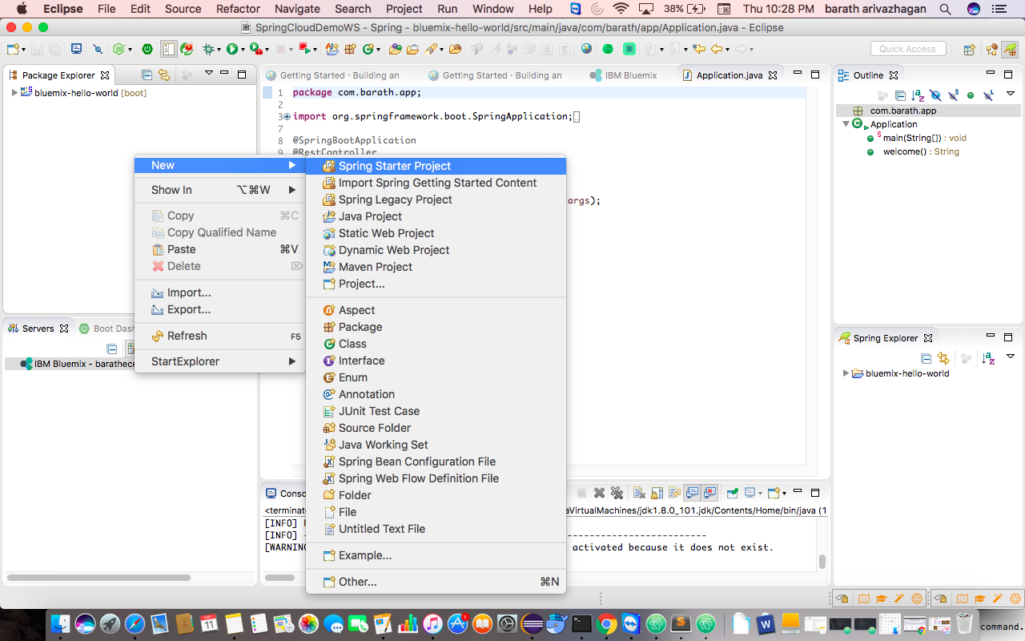

**Step 9:** Create a simple controller to test the application in the main class .

**@SpringBootApplication**

**@RestController**

**public class Application {**

**public static void main(String[] args) {**

**SpringApplication.run(Application.class, args);**

**}**

**@RequestMapping("/")**

**public String welcome(){**

**return "Welcome to Bluemix learning";**

**}**

**}**

**Step 10 :** For example : In this case I have created a bluemix-hello-world project . Once done , **Right click on the project —> Run as —> Run on server**

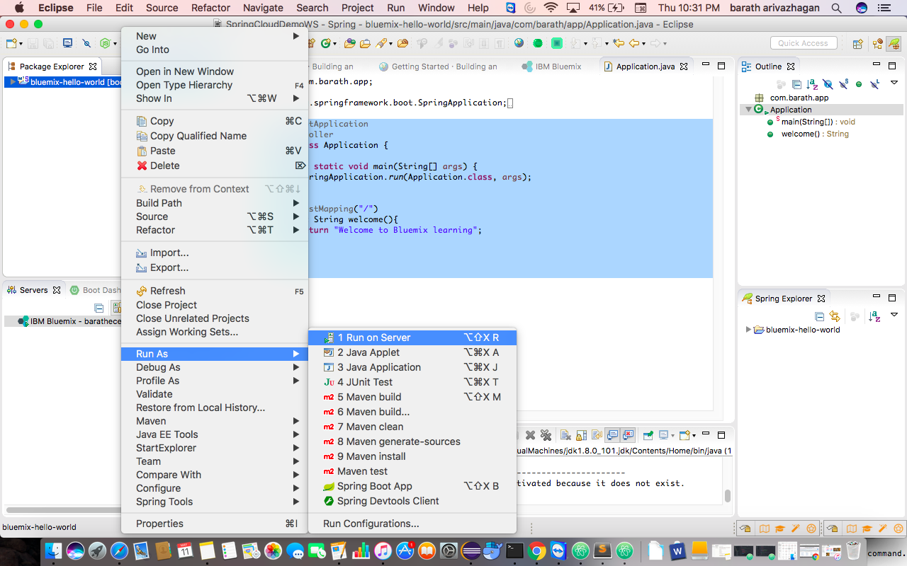

**Step 11 : Select IBM Bluemix server s below and deploy the application by clicking finish button**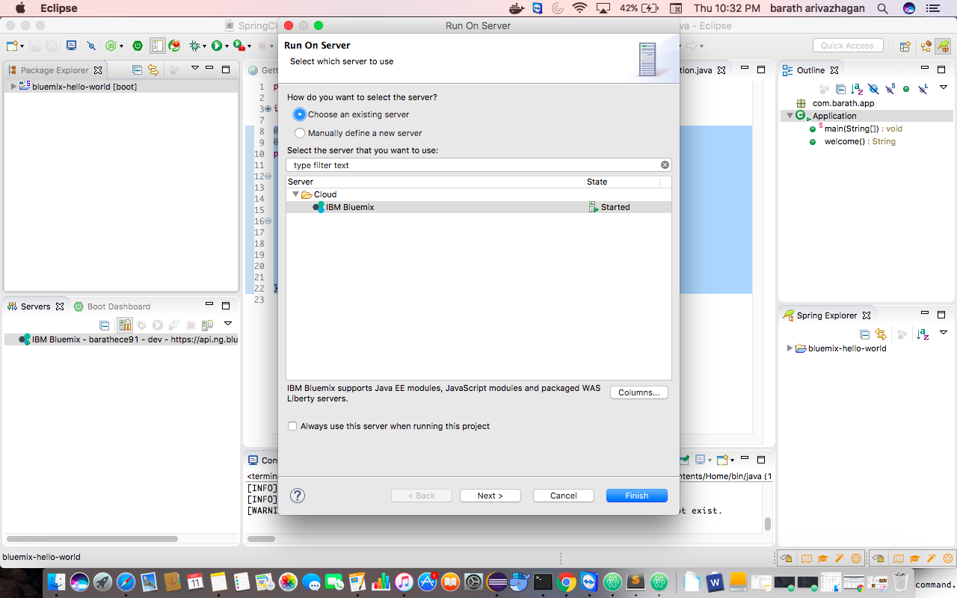

**Step 12 :** Provide the application details as below :

enter the application name and build pack is optional. Click on save manifest file as it will act as reference for building other applications.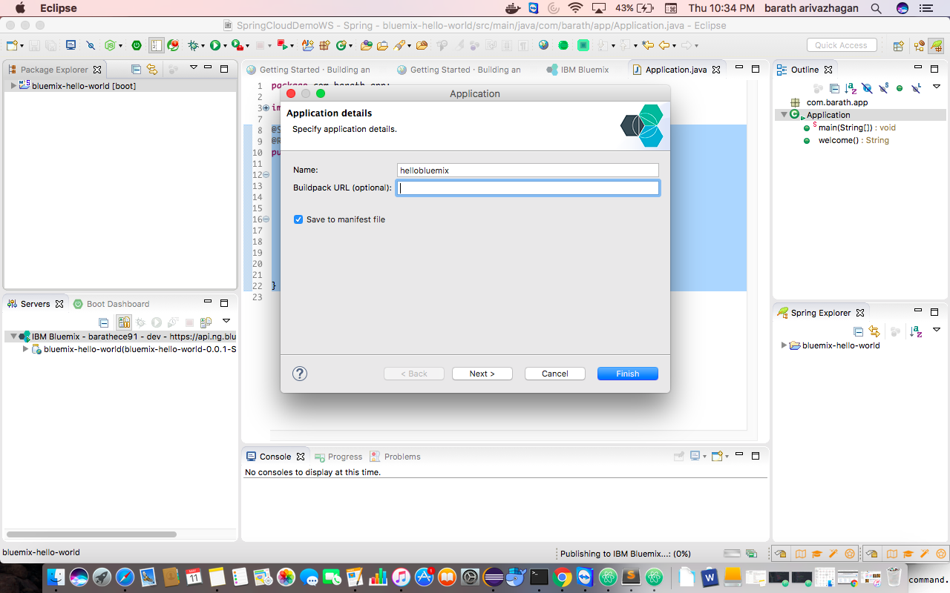

**Step 13:** Click on Next button and verify the details displayed :

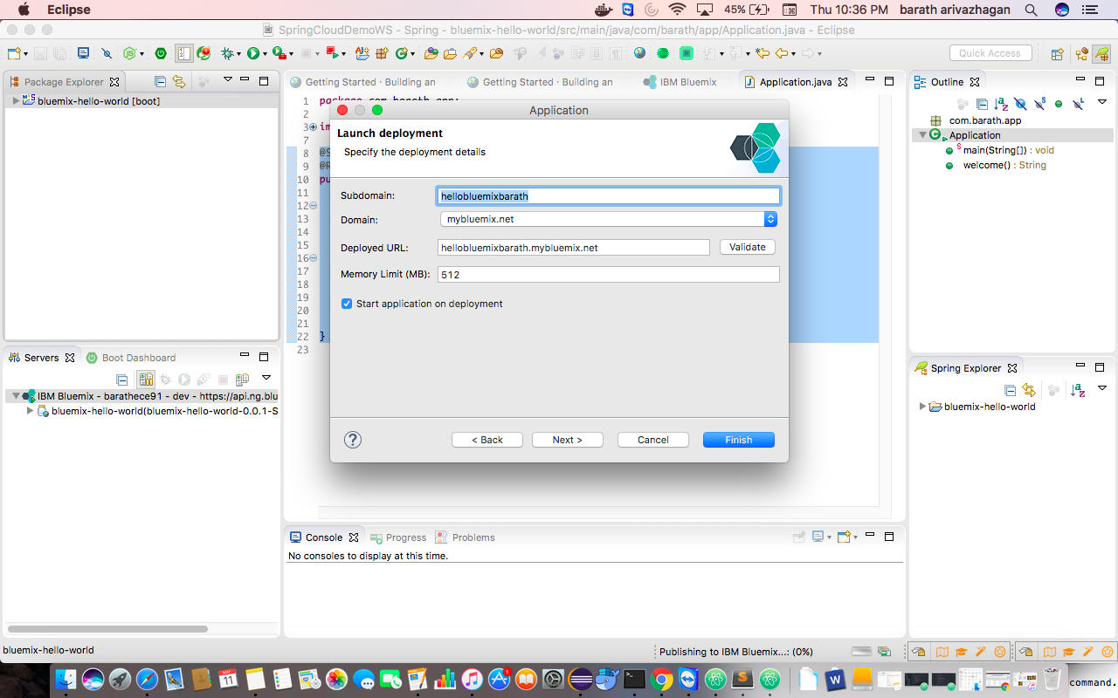

**Note: if it displays error that the name of the application is already taken, try entering different name that is available.**

**Step 14: Click on finish to deploy the application .**

Application will get staged and get deployed to IBM blue mix cloud and we can view the staging logs in the Eclipse console like below :

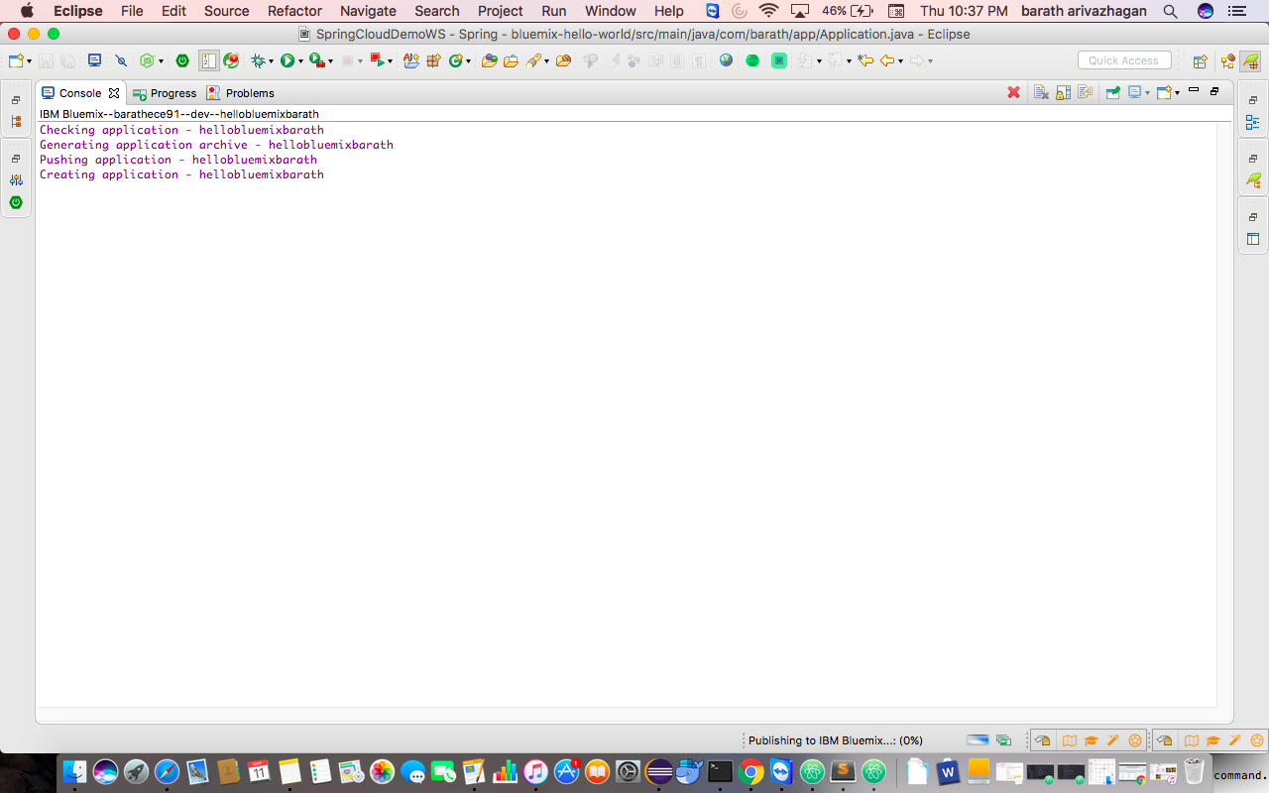

**Step 15:** Login into Bluemix account with the credentials

**<https://console.au-syd.bluemix.net/>**

**Once Logged in, we can view the application deployed :**

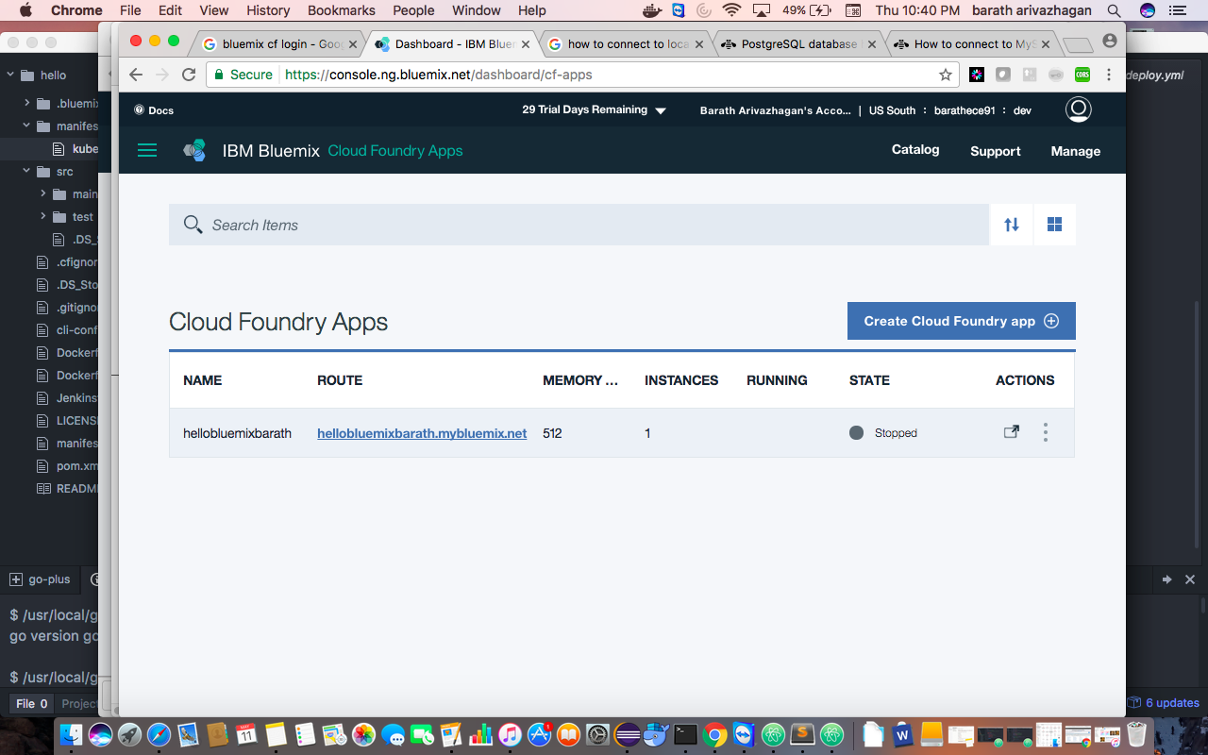

**Step 16:** Test the application by clicking on the route **:**

**In this case : <https://hellobluemixbarath.mybluemix.net/>**

